**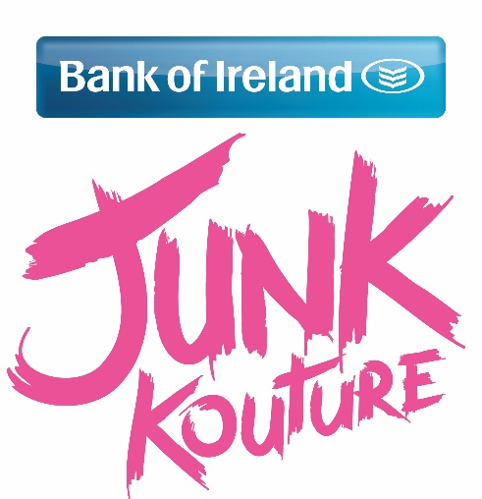  
Press ReleasE**

**Creative dublin Students set to perform at bank of ireland junk kouture regional finals**

**33 incredible dublin designers qualify!**

320 Regional Finalists have been announced and 80 creative students from the East are eagerly preparing to take to the Helix stage in Dublin on March 7th 2016 for the Bank of Ireland Junk Kouture Eastern Regional Final.  Hosted by Ed and Fitzy from iRadio, the audience is in for a treat as 80 talented students will showcase their couture creations made from rubbish and recycled materials in a performance accompanied to music.

An amazing thirty three entries from Dublin have been lucky enough to be chosen as one of the Eastern 80 regional finalists. Four of which were from Loreto College, St Stephens Green – “Electric Ombre”, “Diaphanous”, “Angelic Ammunition” and “Noinin”. All teams from Loreto College, St. Stephens Green were mentored by their art teacher Sarah Fynes. Old Bawn Community School, Tallaght’s design “Uptown Punk” is through to the regional finals, helped by their art teacher Mairead Ryan. “Glamourina” from St Louis High School, Rathmines is through to the regional finals, supported by their art teacher Caroline Gaynor. Two teams from Mount Sackville Secondary School, Chapelizod are through to the regional finals with their designs “Cap-tivating Egyptian” and “Credit Crunch”. The two teams were helped along the way by their art teacher Ms. Murphy. The Institute of Education, Dublin’s design “Going Postal” is through to the regional finals, mentored by their art teacher Maura Parkinson. Our Ladys Terenure, saw three teams through to the regional finals with their designs “Written news” ,“Black Swan” and “Pipeline”. All teams were mentored by their art teacher Dee Maguire. Rathdown School, Glenageary’s design ”Cold Shoulder” is through to the regional finals, helped by their art teacher Dermot Flynn.

The regional finals have a strong judging panel with main judges Tracy Fahey (L.S.A.D Educator), Lorna Mc Gee (Vogue India) and Rob Condon (Stylist) joined by previous winner Orla O’Hagan who has first-hand experience of competing in the Bank of Ireland Junk Kouture competition and understands the pressures and challenges of the regional finalists.Louis Walsh and Vogue Williams are set to join the panel for the Grand Final in the 3 Arena on April 14th for what promises to be a fashion extravaganza.

Speaking about the regional finals, Laura Lynch, Head of Youth Banking at Bank of Ireland said; “The calibre of designs for this year’s competition is incredible. With every entry being uniquely choreographed to music, we are really excited to see the models bring their creations to life on stage at the Regional finals. As Ireland’s leading bank for students we are delighted and proud to sponsor the Bank of Ireland Junk Kouture 2016. We wish everyone the best of luck in the next stage of the competition and remind finalists to get innovative about how they gather support through the Bank of Ireland Junk Kouture voting app.”

As part of the judging process, the public can get involved by casting a vote for their favourite design through the Bank of Ireland Junk Kouture voting app. Accessed through the BOIStudents Facebook page ([www.facebook.com/BOIstudents](http://www.facebook.com/BOIstudents)), voting opens for one week before the regional competitions from 9am Monday 22nd February to 12 midnight Friday 26th February. Individuals can cast a single vote every 24hours. Votes account for 10% of the final mark and can make a huge difference in such a heated competition.  Bank of Ireland is encouraging students to think innovatively about how they gather support through the voting app with a special Bank of Ireland Award in the mix for the Most Innovative Designer at the National Final in April.

With almost 3,000 students, the competition has seen the greatest number of entries to date, making the judging process the toughest yet. The teams will be competing to earn their place in the Grand finals in the hope of walking away with the top prize of €2,500 for their school, iPad Minis and €500 cash for the team. This year’s contestants could also be in with a chance to win a trip to the Royal Film Premiere in London or even a Scholarship to attend the Limerick School of Art and Design. This year has seen the introduction of two news prizes – “Most Unusual Material Prize” and “CoderDojo Techno/Wearables Prize”.

Tickets are on sale now from [www.thehelix.ie](http://www.thehelix.ie) or from The Helix box office.

Good Luck to all teams involved in the Regional finals.

[WEBSITE](http://www.junkkouture.com) | [FACEBOOK](https://www.facebook.com/junkkouture?ref=ts&fref=ts) | [TWITTER](https://twitter.com/junkkouture)

**/ENDS/**

**For further press information please contact:**

Sara Ryan on: +353 87 746 0922 / [sara@junkkouture.com](mailto:sara@junkkouture.com)

**Notes to Editors:**

**About Junk Kouture:**

**The Bank of Ireland Junk Kouture Recycled Fashion Competition 2016** hasshowcased jaw- dropping recycled designs from talented secondary school students across the nation since 2009.

Each of the finalists have been hand-picked by our Junk judges, and on March 7th they will be tasked with the decision of finding the budding designers who progress to the Grand Final in The 3 Arena on April 14th.

**About Bank of Ireland:**

Bank of Ireland Secondary Schools programme is a comprehensive financial education programme for schools that can be adapted to meet the needs of schools at all levels.

Junk Kouture is an important part of a range of fun and engaging initiatives supported by Bank of Ireland to provide a positive approach to developing students’ understanding of relevant issues to them - everything from teamwork, personal responsibility and striving for achievement.