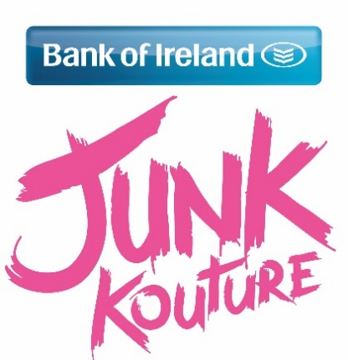

**Creative Students fROM Kilkenny set to perform in THE 3 Arena**

What do Justin Bieber, Adele and secondary school students from Kilkenny have in common? Well on the 14th of April 2016 they can all say that they have performed in the 3 Arena Dublin!

Creative students from Castlecomer Community School will take to Ireland’s most prestigious stage to showcase their couture creation made from rubbish as part of the Bank of Ireland Junk Kouture competition hosted by Xpose’s Glenda Gilson.

One design from the school has achieved a place in the grand final; *Ethereal Fish* was designed by Michelle Farrell, Emma Coogan and Ellie Boland from acetate sheets and their art teacher was Robert Dunne.

This team successfully competed in the southern regional final at the start of the month, with only twenty designs making it through to the Grand Final. The Kilkenny students now hope to walk away with the top prize of €2,500 for their school, iPad Minis and €500 cash for the team.

Students could also win the chance to walk the red carpet at the Royal Film Premiere in London with the Bank of Ireland Glamour prize or even a Limerick School of Art and Design Scholarship to cover their fees at the college for one full year of study.

Each of the grand finalists will be adjudicated by our lovely Junk judges; model and DJ Vogue Williams; stylist and TV presenter, Rob Condon; design educator from L.S.A.D., Dr Tracy Fahey; Vogue India’s Lorna McGee; and not forgetting the one and only Louis Walsh.

Laura Lynch, Head of Youth Banking at Bank of Ireland said; “This year’s Grand Finalists are truly spectacular and we have been amazed by the sheer imagination and talent displayed by these young student designers. As Ireland’s leading bank for students we are incredibly proud to be able to bring Bank of Ireland Junk Kouture to schools nationwide as part of our comprehensive second level programme. We are very excited to see the models perform on stage at the 3Arena and the entire audience is in for an exceptional treat. We wish everyone involved the best of luck and remind finalists to get innovative about how they gather support through the Bank of Ireland Junk Kouture voting app.”

As part of the judging process, the public can get involved by casting a vote for their favourite design through the Bank of Ireland Junk Kouture voting app. Accessed through the BOIStudents Facebook page ([www.facebook.com/BOIstudents](http://www.facebook.com/BOIstudents)), voting opens 9am Monday 28th March and will close midnight Friday 8th April. Individuals can cast a single vote every 24hours. Votes account for 10% of the final mark and can make a huge difference in such a heated competition.  Bank of Ireland is encouraging students to think innovatively about how they gather support through the voting app with the special Bank of Ireland Award in the mix for the most enterprising team.

In addition to 80 of Ireland’s finest junk designers showcasing their work with entertaining catwalk performances, a host of special guests will be in attendance on the night! Warm up will be provided by the native Irish singing band Seo Linn, who are well known for their take on Avicii’s hit ‘Wake Me Up’, before Louis Walsh’s new up and coming 6-piece boyband Hometown perform their two number 1 singles Where I Belong and Cry for Help.

Tickets are on sale now available from all Ticketmaster outlets nationwide.

**/ENDS/**

**For further press information please contact:**

Sara Ryan on +353 877 460 922 / [info@junkkouture.com](mailto:info@junkkouture.com)

**About:**

**The Bank of Ireland Junk Kouture Recycled Fashion Competition 2016** hasshowcased jaw- dropping recycled designs from talented secondary school students across the nation since 2009.

Each of the finalists have been hand-picked by our Junk judges, and on April 14th they will be tasked with the decision of finding the budding designers who will be crowned this year’s winner.

**Bank of Ireland:**

Bank of Ireland Secondary Schools programme is a comprehensive financial education programme for schools that can be adapted to meet the needs of schools at all levels.

Junk Kouture is an important part of a range of fun and engaging initiatives supported by Bank of Ireland to provide a positive approach to developing students’ understanding of relevant issues to them - everything from teamwork, personal responsibility and striving for achievement.